PROJECT PROPOSAL
Smart Home Energy Monitoring & Automation Dashboard
(Full-Stack IoT-Based System)

EXECUTIVE SUMMARY
In modern households, inefficient energy usage, lack of real-time visibility into electricity consumption, and limited remote control capabilities result in unnecessary power wastage and operational inconvenience. Traditional electrical systems do not provide appliance-level monitoring, automated energy optimization, or centralized digital control, leading to increased energy costs and reduced system efficiency.
To address these challenges, the Smart Home Energy Monitoring & Automation Dashboard is proposed as a full-stack IoT-based solution. The system integrates an ESP32 microcontroller, an energy measurement module, and a cloud-connected web dashboard to enable real-time monitoring of voltage, current, power, and energy consumption. Users can remotely control household appliances, visualize historical energy usage, and apply automated optimization logic through a secure web interface.
The platform follows a modular client–server architecture consisting of a React-based frontend, a Node.js/Express backend, and a MongoDB database. Energy data acquired from the IoT layer is transmitted to the backend for storage and analysis, while the frontend dashboard provides interactive visualization and control features. The system improves energy efficiency using real-time measurement, automated scheduling, idle-time detection, and closed-loop control mechanisms.
Overall, the proposed solution delivers a scalable and technically robust smart home energy management system that enhances operational efficiency, enables intelligent energy optimization, and provides a foundation for future smart home and Industry 4.0 applications.

BACKGROUND AND PROBLEM STATEMENT
2.1 Problem Definition
Conventional household electrical systems operate without real-time monitoring, appliance-level energy tracking, or intelligent control mechanisms. As a result, users are unable to quantify real-time power consumption, detect idle-time wastage, or optimize load usage dynamically. Appliances often remain operational beyond required durations, leading to inefficient energy utilization and increased electricity costs.
Additionally, existing systems lack centralized digital platforms for monitoring and controlling appliances remotely. There is no automated mechanism to schedule appliance operation, manage peak loads, or detect abnormal power consumption. This results in operational inefficiencies, safety risks, and limited scalability for future smart home integration.
Therefore, there is a need for a technically robust smart home system that provides real-time energy measurement, remote appliance control, automated optimization, and data-driven analytics to improve household energy efficiency.

2.2 Proposed Solution
To address the identified limitations, the Smart Home Energy Monitoring & Automation Dashboard is proposed as a full-stack IoT-based platform. The system integrates an ESP32 microcontroller with a relay module and an energy meter (PZEM-004T) to measure real-time voltage, current, power, and cumulative energy consumption.
The ESP32 transmits energy data to a backend server via Wi-Fi using REST APIs or MQTT. The backend processes and stores the data in a MongoDB database and exposes secure endpoints for appliance control and data retrieval. A React-based frontend dashboard provides secure user authentication, real-time appliance control, and interactive visualization of energy usage.
The system incorporates automated control logic such as idle-time detection, scheduled operation, peak-load management, and abnormal power detection. These mechanisms enable dynamic load optimization and minimize unnecessary energy consumption. The modular architecture ensures scalability, maintainability, and future feature extensibility.

PROJECT OBJECTIVES
3.1 Primary Objectives
Objective 1: Develop Real-Time Energy Monitoring System
- Measure voltage, current, power, and energy using an energy meter
- Transmit real-time energy data to a cloud backend
- Store time-series energy data for historical analysis
- Display real-time readings on a web dashboard
Objective 2: Implement Remote Appliance Control
- Enable ON/OFF control of appliances using relays
- Provide secure remote control via web interface
- Synchronize device states between hardware and dashboard
Objective 3: Integrate Automated Energy Optimization Logic
- Implement idle-time detection and auto cut-off
- Support scheduled appliance operation
- Detect peak load and apply load shedding
- Identify abnormal power consumption
Objective 4: Develop Secure Full-Stack Infrastructure
- Implement JWT-based authentication
- Build REST APIs for device and energy management
- Design MongoDB schemas for users, devices, and energy logs
- Ensure secure data transmission and access control

3.2 Secondary Objectives
Objective 5: Build Interactive Analytics Dashboard
- Display daily and monthly energy usage charts
- Provide appliance-wise energy breakdown
- Enable data export and reporting
Objective 6: Ensure System Scalability and Maintainability
- Design modular backend services
- Enable addition of new appliances and users
- Prepare system for mobile and voice integration
Objective 7: Enhance Safety and Reliability
- Detect overload conditions
- Prevent continuous idle usage
- Log abnormal power events

SCOPE OF WORK
4.1 In-Scope Features
User Authentication & Management
- User registration and login
- JWT-based secure session handling
- Role-based access control
- Profile management
Energy Monitoring & Data Logging
- Real-time voltage, current, and power measurement
- Energy consumption logging
- Historical data storage
Appliance Control & Automation
- Relay-based ON/OFF control
- Scheduled appliance operation
- Idle-time auto cut-off
Analytics & Visualization
- Daily and monthly charts
- Appliance-wise energy usage
- Interactive dashboard UI
Backend & API Services
- REST APIs for energy data
- APIs for device control
- Secure database access

PROJECT STRUCTURE AND MODULES
5.1 Frontend Modules (4 Modules)
Module 1: User Authentication & Profile UI
Duration: 1 week
Components:
- Login and signup pages
- JWT session handling
- User profile UI
Module 2: Dashboard & Device Control UI
Duration: 1.5 weeks
Components:
- Appliance cards
- ON/OFF toggle buttons
- Live power display
Module 3: Analytics & Visualization UI
Duration: 1.5 weeks
Components:
- Daily energy chart
- Monthly energy chart
- Appliance-wise usage graph
Module 4: Alerts & Scheduling UI
Duration: 1 week
Components:
- Scheduling interface
- Alert display panel
- Automation controls

5.2 Backend Modules (4 Modules)
Module 5: Authentication & User Service
Duration: 1 week
Components:
- JWT authentication
- User profile management
- Role validation
Module 6: Device & Energy Management Service
Duration: 1.5 weeks
Components:
- Energy data ingestion
- Device state handling
- Data validation
Module 7: Automation & Optimization Engine
Duration: 1.5 weeks
Components:
- Idle-time detection logic
- Scheduling engine
- Peak load detection
Module 8: Analytics & Reporting Service
Duration: 1 week
Components:
- Data aggregation
- Chart data generation
- Report export

TECHNICAL ARCHITECTURE
6.1 Technology Stack
Frontend:
- React.js
- HTML5, CSS3
- Chart.js / Plotly
- Axios
Backend:
- Node.js
- Express.js
- JWT Authentication
- REST APIs
Database:
- MongoDB
IoT Layer:
- ESP32
- Relay Module
- Energy Meter (PZEM-004T)

6.2 System Architecture
User → React Dashboard → Node.js Backend → MongoDB
↑
ESP32 + Energy Meter + Relays

6.3 Key Design Patterns
- MVC Architecture
- Service Layer Pattern
- Repository Pattern
- JWT-Based Stateless Authentication
- RESTful API Design
- Component-Based Frontend

SUCCESS CRITERIA
- Functional Effectiveness
- Accurate real-time energy measurement
- Reliable appliance control
- Performance & Reliability
- Low API response time
- Stable data transmission
- Security
- Secure authentication
- Protected APIs
- Scalability
- Support multiple appliances
- Add new users easily
- Energy Optimization
- Idle-time cut-off
- Scheduled control
- Peak-load handling

CONCLUSION
The Smart Home Energy Monitoring & Automation Dashboard demonstrates a technically robust full-stack IoT solution for real-time energy management and appliance automation. By integrating hardware-level sensing with cloud-based analytics and control, the system enables dynamic energy optimization and intelligent load management.
The modular architecture ensures scalability, maintainability, and future extensibility. The system provides a strong foundation for advanced smart home features such as AI-based energy prediction, mobile integration, and voice control. Overall, the successful implementation of this project validates its potential for real-world smart energy management applications.

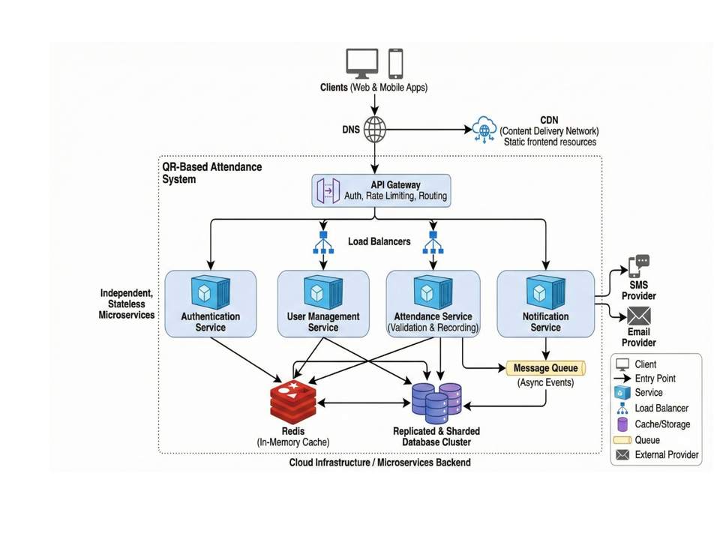

Team Contribution:
Kartik Soni 24BCS11202– Backend, IoT Integration, System Architecture
Sahil Kumar 24BCS11637 – Frontend, UI Design, Documentation

